FIRA AndroSot

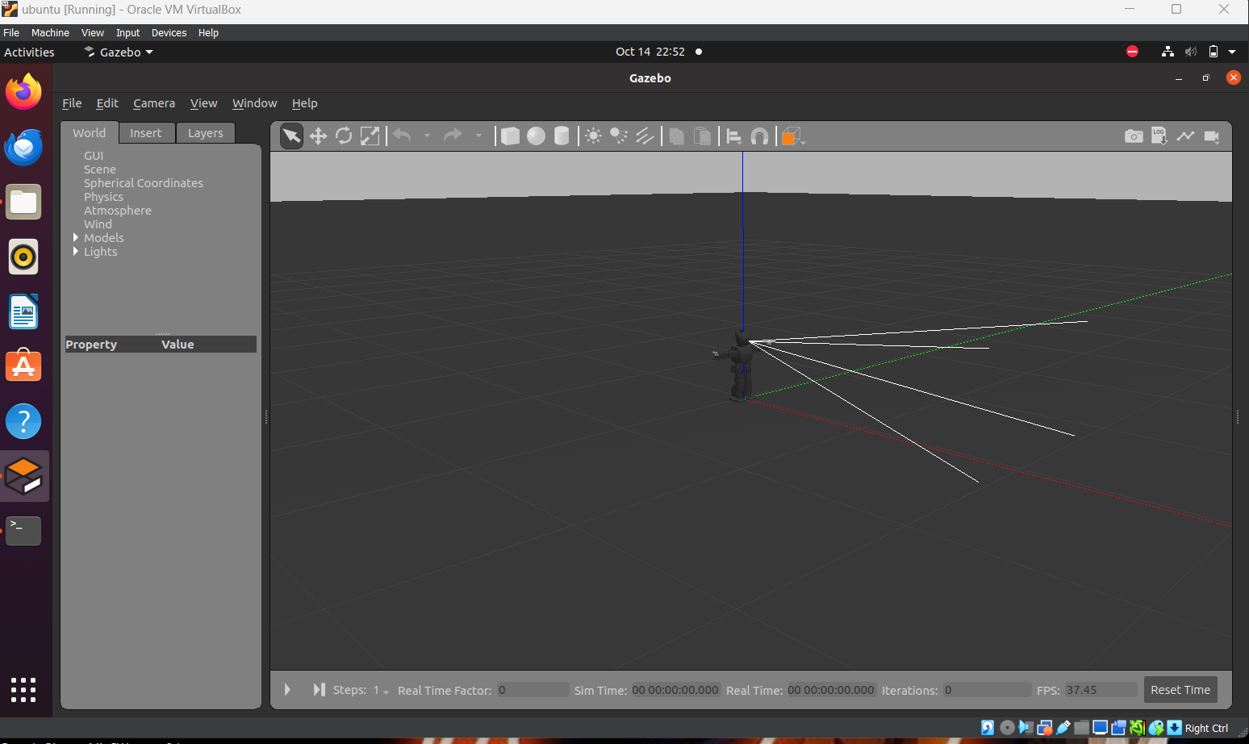

- Worked on assigment to run motor through ROS.

- Setup and run ROS – gazebo simulation of BIOLOID .Starting with launching the bot in a gaezebo environment and then primarly running the walking command .

- Working on bioloid we get to know about mulitiple errors and how we can detect our mistake and how can we fix them.

- Also involved in inspecting code files

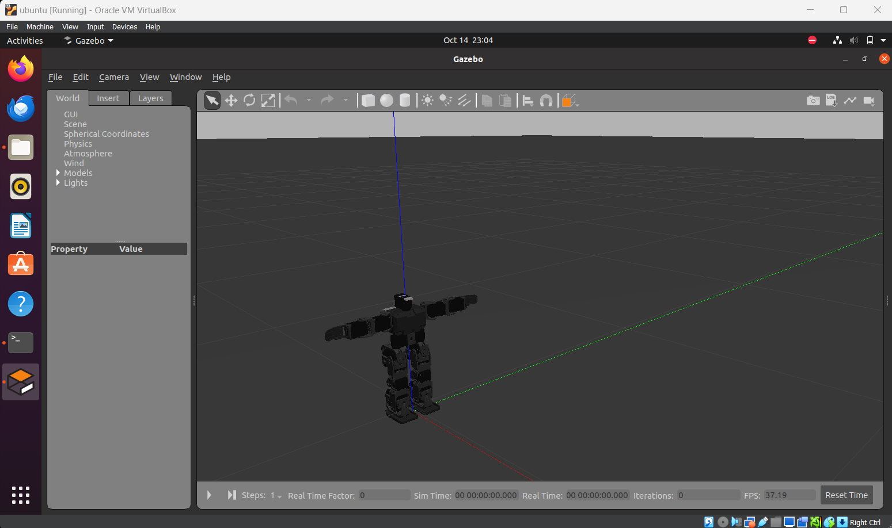
- Created and launched some worlds to test obstacle avoidance code .Used gazebo to create different environment as per the requirement .

- Using the world launch file for launching world in gazebo.

- Then launchind the bioloid in the same world and runing the python code file for the required action.

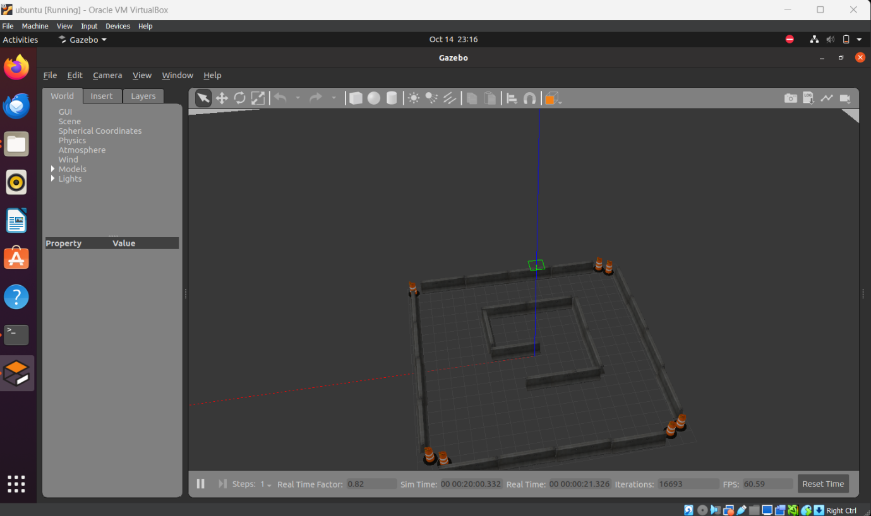

- Learned basics of creating URDF,( joining joints manually with xml code ), different types of sensors and creating controllers . We learned how we can modify the gazebo model using its URDF file. Worked on controller for obstacles avoidance (using lidar sensor laser scan ) also learned about some other sensor and their functions .

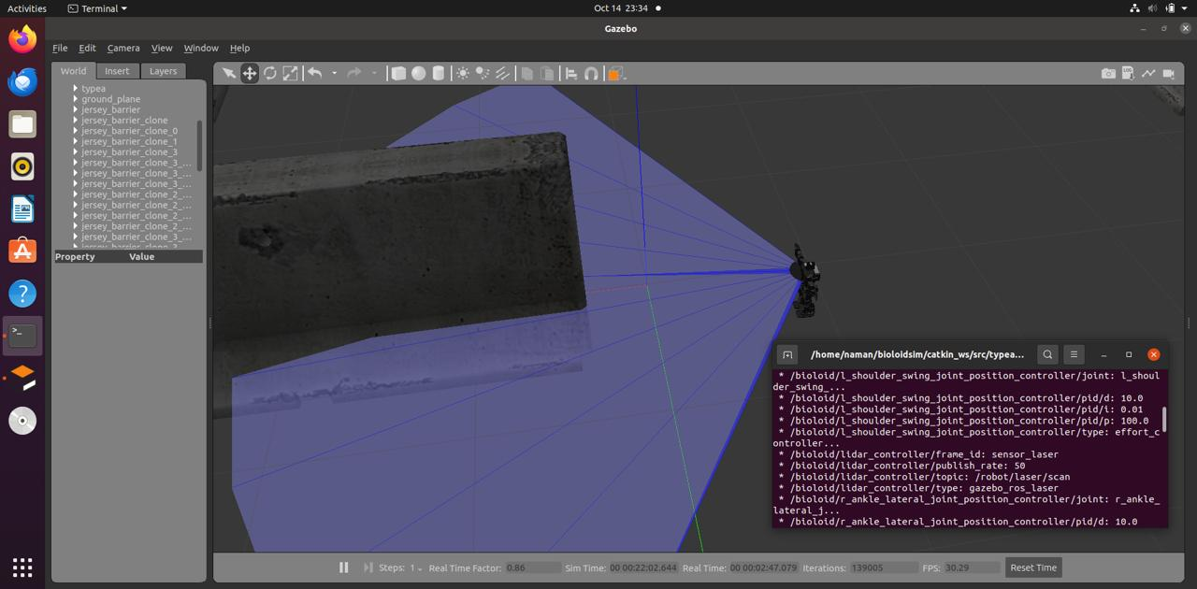

- Currently focused on creating a environment as per the rules of competition to test our bot and code to get idea of scope of improvement if required . It involves proper dimension, position of different objects ,colour of obstacles and other part of the environment.

- Also working on environment for the football competition, considering all dimension and rules as per the rule mentioned on the site to simulate bot to see their movements and their performance.

